Data Modification 4(using MySQL server)

UPDATE Location

SET LocName = 'Gate'

WHERE LocNo= 'L107';

Before Modification:

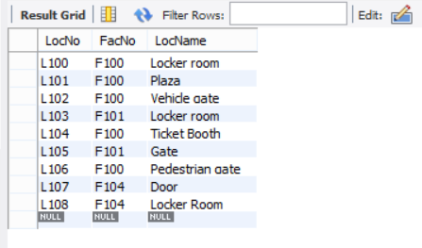

Resulting Table Screenshot:

